Michael Surdek
Project Management Plan
ECO-Trans
Final Project Plan

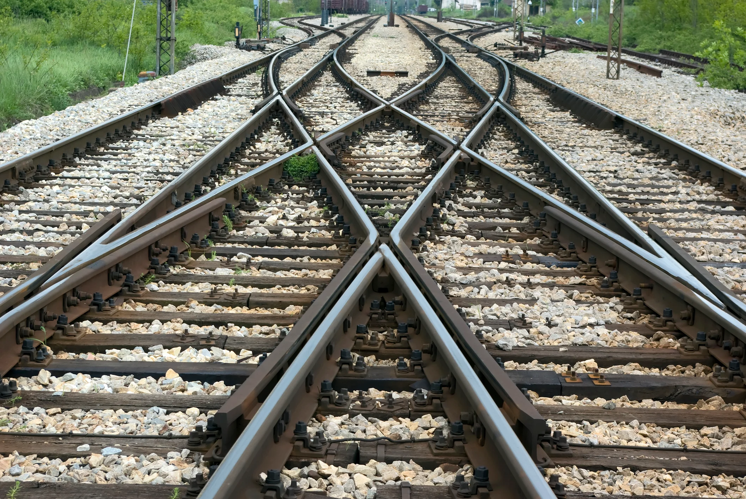

Submitted to:
Dr. Randy Butler
Project Planning
Business Requirement
ECO-Trans is in the midst of project in which they plan to install their high-tech transportation equipment throughout a fleet of Sunshine Rail Transit’s trains. The project includes a list of phases that have been planned as well as additional requests and developing situations, which altogether make up the business requirements for the project. It is important to gather and prioritize requirements in the planning phase of the project and throughout the preliminary stages. Doing so “ensures that the scope of the project encompasses all of these needs and that the project will meet the most important stakeholders' requirements to their satisfaction.” (MindEdge Module 3) For ECO-Tran’s project, the basic requirements derive from the implementation schedule, including testing, installing, and training. All of these activities are required for the successful development of the project and are therefore likely to be classified as high priority. Additional requirements appeared early in the project, including exchanging key components and managing conflict between team members. These activities may be prioritized at specific times, but they are generally of lower priority than the initial requirements.
Subject Matter Experts
In order to thoroughly plan for the project, it is wise to collect both established and potential requirements with the assistance of subject matter experts. This collection process can include methods such as interviews, questionnaires, diagramming, and reviewing lessons learned from previous projects. The project manager, Astrid Varga, should include project team members and key stakeholders in the process of collecting requirements. She should attempt to gather input from her ECO-Trans colleagues including training specialists, Dominic Vonn and Marielle Beauchamp, and software specialist, Roland Letessier, as well as from SRT members such as John Schaller, Mark Osborne, Bernie Hays, and Ed Hallman. Varga should analyze documentation and review lessons learned from previous projects, which will help her develop baseline requirements and appropriate questions that will provide effective feedback. She can utilize these questions in interviews with important and readily-available stakeholders as well as in questionnaires with those she cannot access directly. With this input from all relevant parties, Varga will be able to organize and categorize the project’s business requirements so that they can be referenced and managed throughout the project life cycle.

Standard Requirements Template
Requirement Number | Requirement Description | Priority
1 | Complete system test on North Central line and document results | Medium
2 | Confirm funding by state transportation authorities and SRT | Medium
3 | Implement equipment for central control room | High
4 | Equip first phase of locomotives with the system | High
5 | Equip entire fleet with the system | High
6 | Complete end user training | Medium
7 | Return defective connection component to supplier and purchase from alternate source | High
8 | Deliver system on time and within SRT’s budget | High
9 | Reassign training specialists to perform end user training earlier than originally planned | Medium
10 | Attend Mark Osborne’s training block to provide a demo for SRT’s locomotice engineers | Low
11 | Resolve conflicts on resource calendar | Medium
12 | Manage conflict between project team members on the SRT side | Low
13 | Handle stakeholder status update requests and other forms of communication | High
14 | Manually inspect new connection components | Low
15 | Reassemble defective terminals in new casings using ECO-Trans extra supply | Medium

Format
The format for collecting and documenting requirements is critical to the overall likelihood of success on the project. Requirements must be gathered in a way that not only considers all input, but also ensures that each established requirement is aligned with the organization’s strategic objectives and can be traced to the needs of an individual or group of stakeholders. There are many benefits of strategic alignment and traceability, including better understanding and buy-in, easier access to resources, and more transparency of potential issues and conflicts. Additionally, projects that are well-aligned and traceable become more clear that they are “done” and are more likely to be viewed as a success at completion.
Project Schedule and Estimates
The project schedule is an important part of the planning phase where key milestones are set to time frames and the duration, costs, and responsible parties are assigned to specific activities. A rudimentary baseline may have been created in the initiating phase, but it can be expanded now that a full list of requirements has been collected. Once the tasks have been established along the timeframe of the entire project, it is possible to estimate the duration cost of labor per day for each task, which provides a better idea of the cost of labor for the entire project.
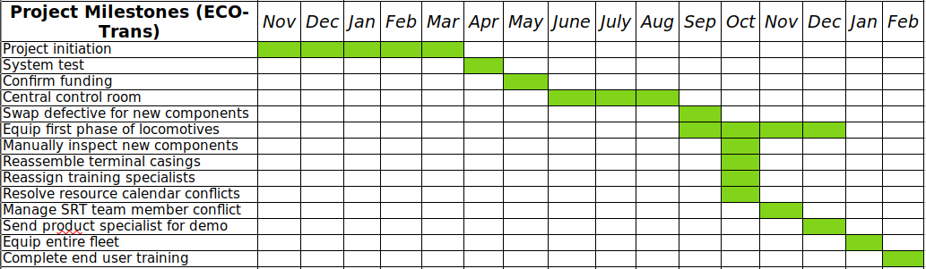

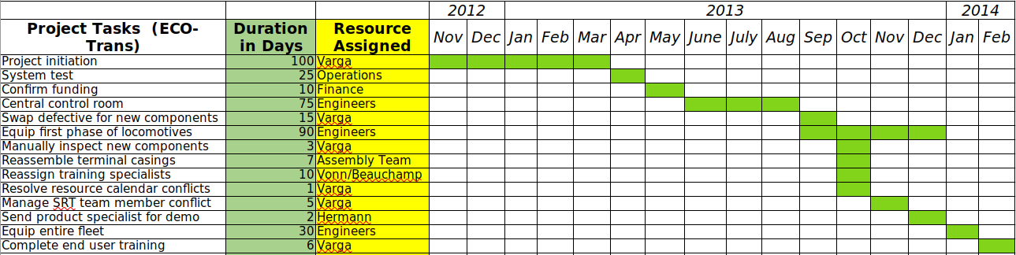
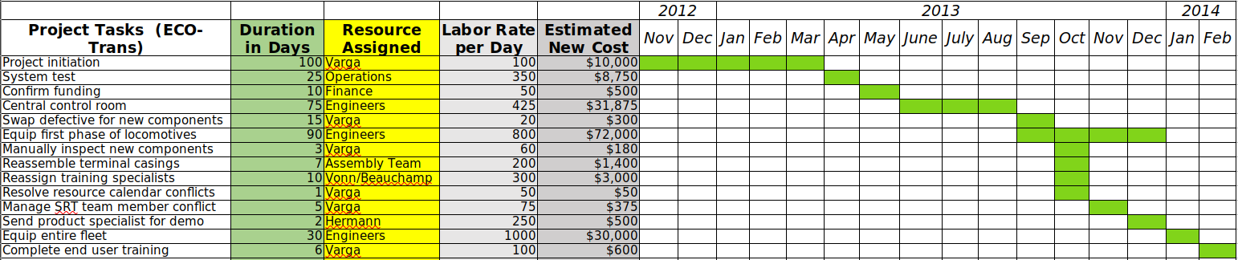
Project Execution
Implementation Approach
With the business requirements and schedule baseline established, now is time to execute the remainder of the ECO-Trans project, and the best implementation approach in this case is waterfall project management. In contrast to agile project management, the waterfall method is effective when a project is conceived as a series of sequential steps that are each executed once and not revisited. This makes sense for the ECO-Trans project because the requirements are established and can be broken down into sequential activities. Waterfall project management “begins with a statement of customer requirements and ends with the creation and consignment of a predetermined deliverable.” (MindEdge Module 3) On this project, the deliverable is a fully equipped fleet of locomotives and a trained staff of engineers. With this approach, Varga is best able to monitor and control the project throughout each step as they were initially planned.
Project Schedule
When projects face the threat of not being completed on schedule, a practitioner has various options to either rearrange or modify planned activities in order to get the project back on track. Activities can be rearranged so that those originally planned in sequence are executed simultaneously, which is called fast-tracking. The main issue for ECO-Trans is the delay on receiving effective connection components. There is a diagram of sequences and dependencies for the process of manufacturing and configuring the terminals, and it shows that the installation of the connection box is on the critical path of the schedule. This means that, due to the delayed activity’s dependencies, fast-tracking is not an option.
The alternatives that involve modifying the activity include crashing, resource leveling, and resource smoothing. “Crashing is done by increasing the resources to the project, which helps make tasks take less time than what they were planned for. Of course, this also adds to the cost of the overall project.” (Simmons) In this case, Varga chose crashing when she decided to return the defective components and order them from a different supplier at a higher price. If she had waited for new components from the original supplier, the project would have been at a risk of more significant delays. Resource leveling is adjusting the start and finish dates in the schedule to align with resource availability and resource smoothing is spreading project activities out among several resources so that work can be completed without exceeding predefined limits. (MindEdge Module 5) If Varga does not receive the new components when she expects, she can try to keep the project on track by resource smoothing. Specifically, now that she needs to manually inspect each of the new components, she could spread the activity out among the team members so that it is completed without taking up days of her own time.

Keep Leadership Apprised
Since the ECO-Trans project involves multiple organizations and a large number of individuals who are interested in the process and results, it is critical to keep everyone informed and to hear and acknowledge their feedback. As with many other project elements, thorough planning of this communication effort will help Varga keep the project on track and make it more likely to be viewed as a success by important stakeholders. The plan should include all of the project's relevant events and individuals, which will ensure that communications are being transmitted in a timely and appropriate fashion.

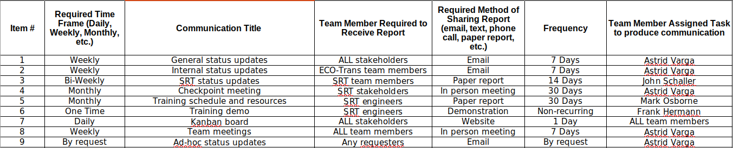
References:
"Module Three: Project Scope, Planning, and Time Management." 2021. MindEdge Inc. Retrieved from https://snhu.mindedgeonline.com/content.php?cid=87451
"Module Five: Project Human Resource, Communications, and Stakeholder Management.” 2021. MindEdge Inc. Retrieved from https://snhu.mindedgeonline.com/content.php?cid=87429
Simmons, Marshall. “Project Crashing in Project Management: Definition & Best Practices.” 2020. projectmanager.com. Retrieved from https://www.projectmanager.com/blog/project-crashing-definition

